Write a mapreduce program to use CombineFileInputFormat. Pass a directory containing multiple small files. The program should be able to pick multiple files in a single mapper.

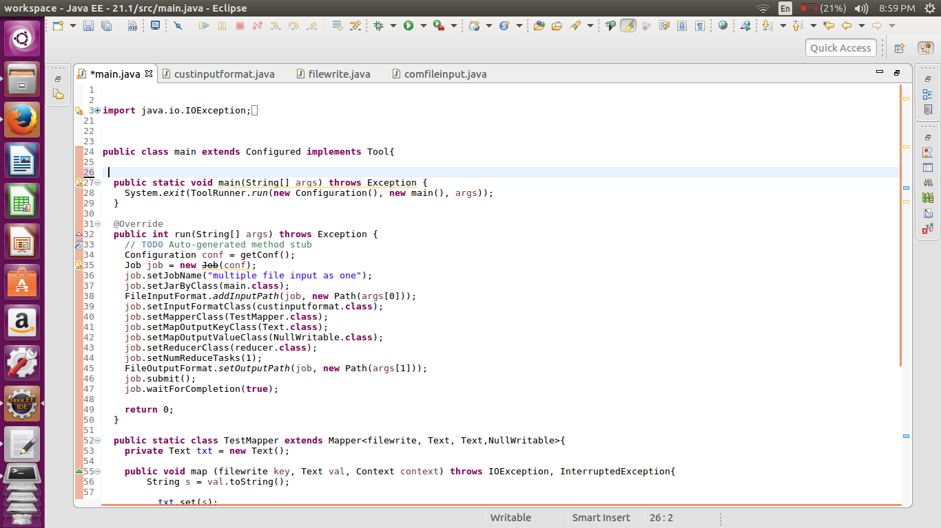

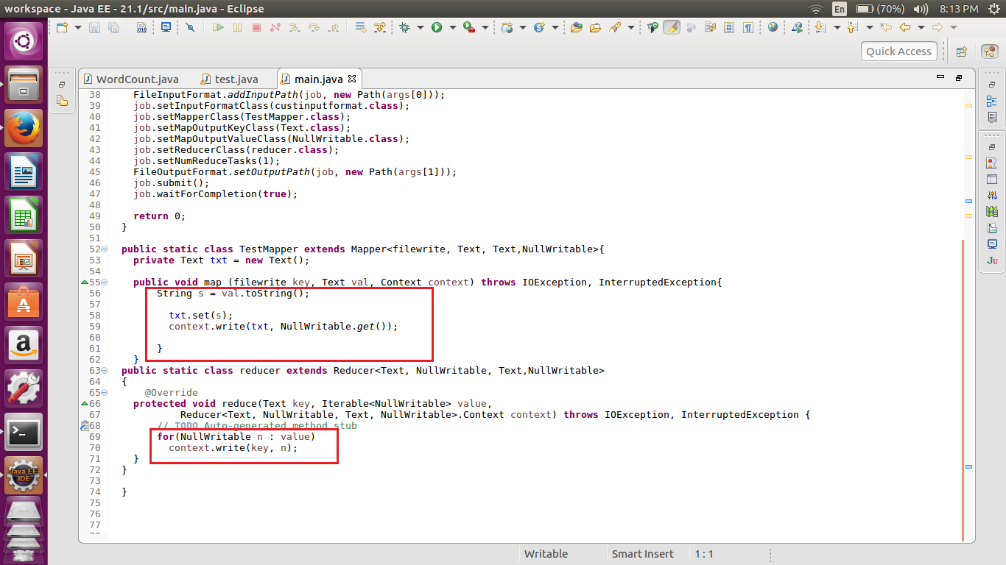

//custom combinefileinputformat

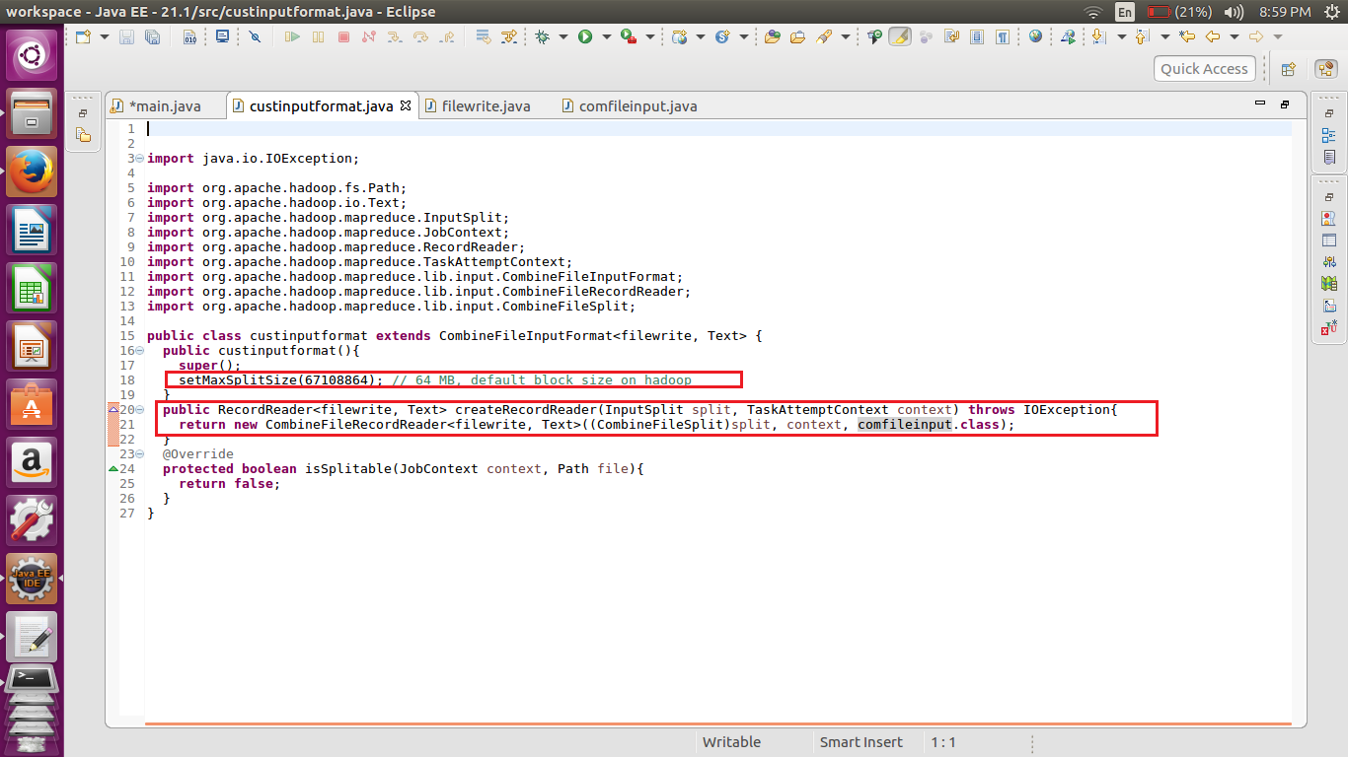

Here in this code we are extending the combinefileinputformat to set the split size and return a custom cobinefileformat.

We have passed confileinput as the argument which is a custom recordreader

//custominput

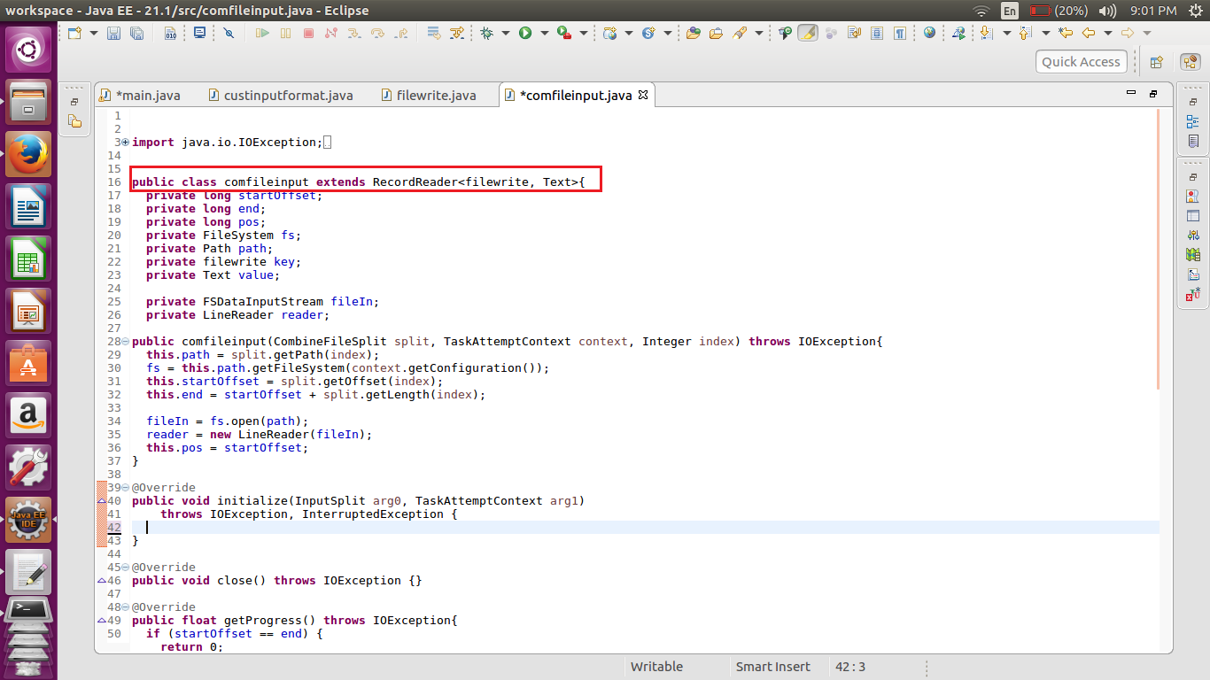

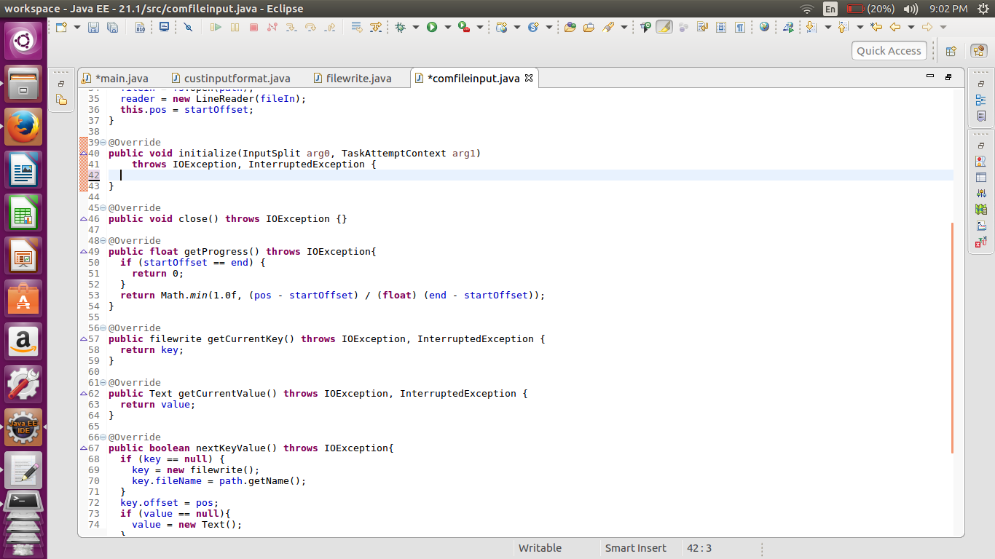

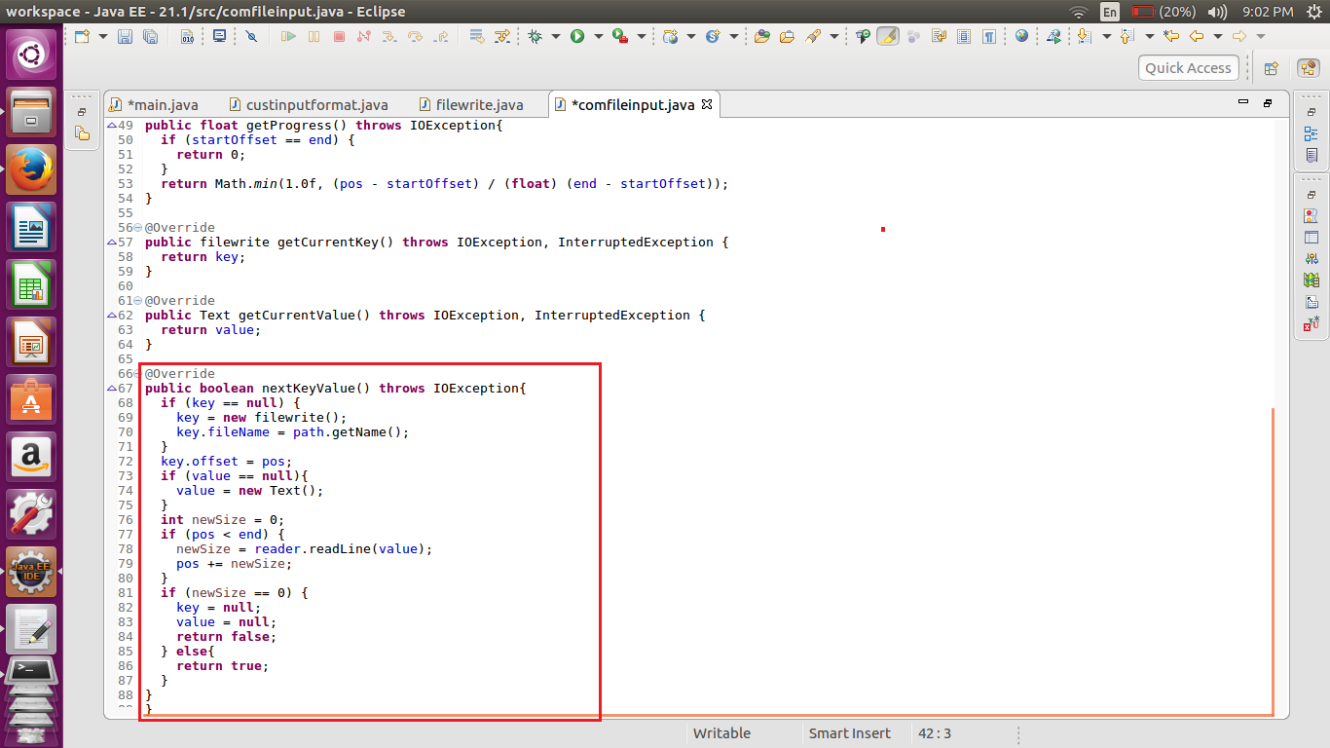

//custom input

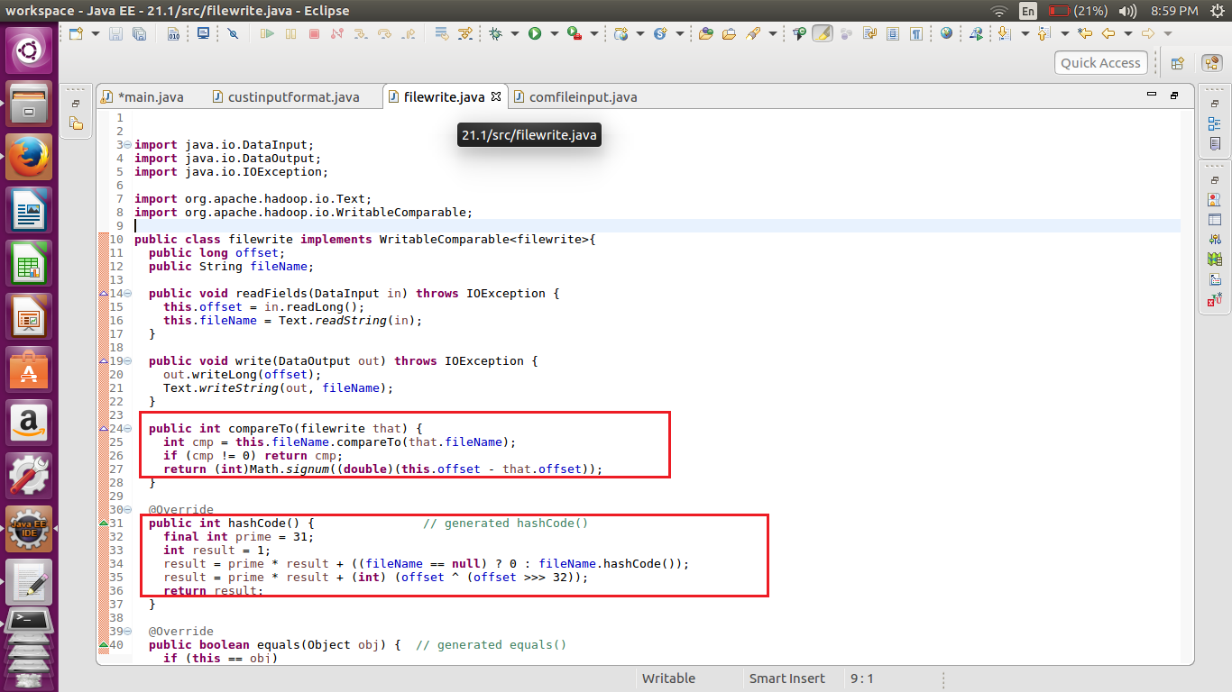

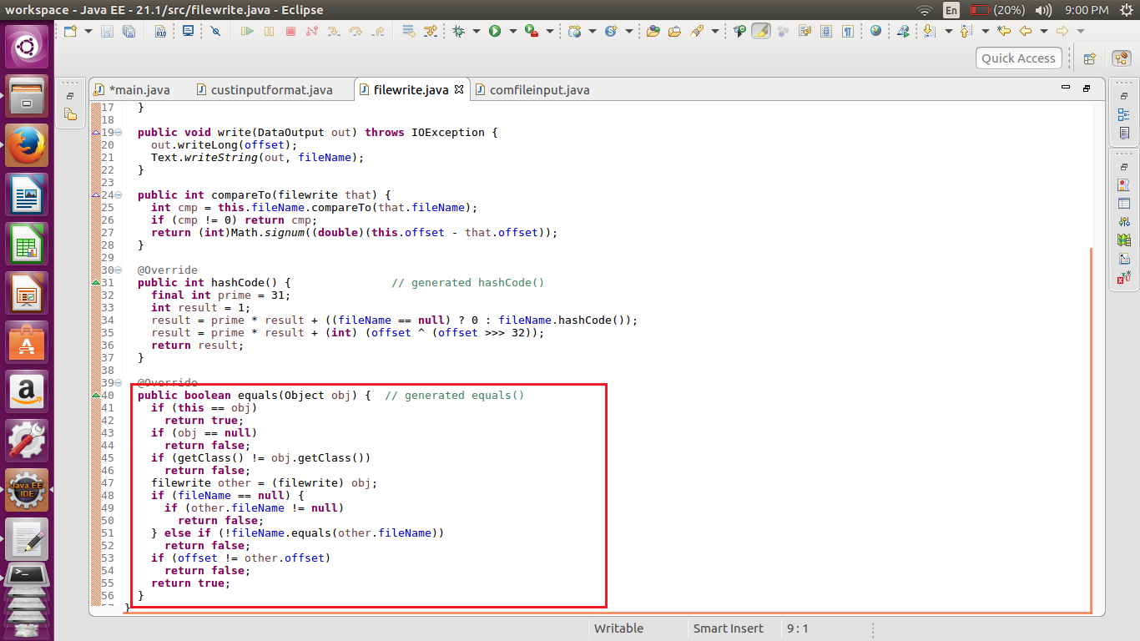

//implementation

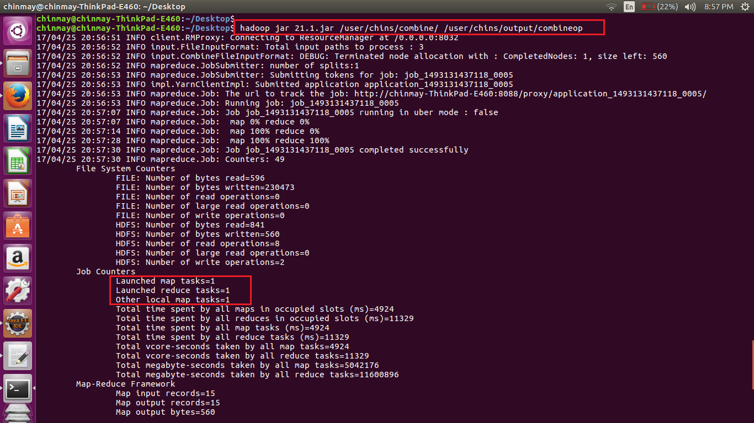

Here we can see that counter showing the number of map tasks are executed is only one

Also the input given as the argument is a directory containing three files.

These file are combine to give us single output.

//input

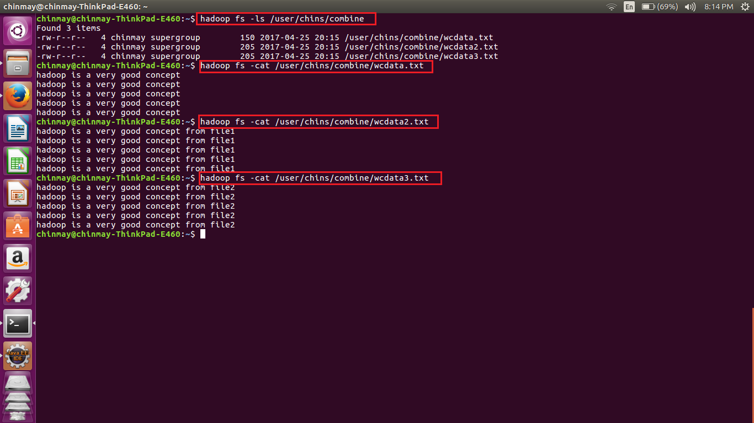

Here we can see that the combine directory has three file with different data.

//output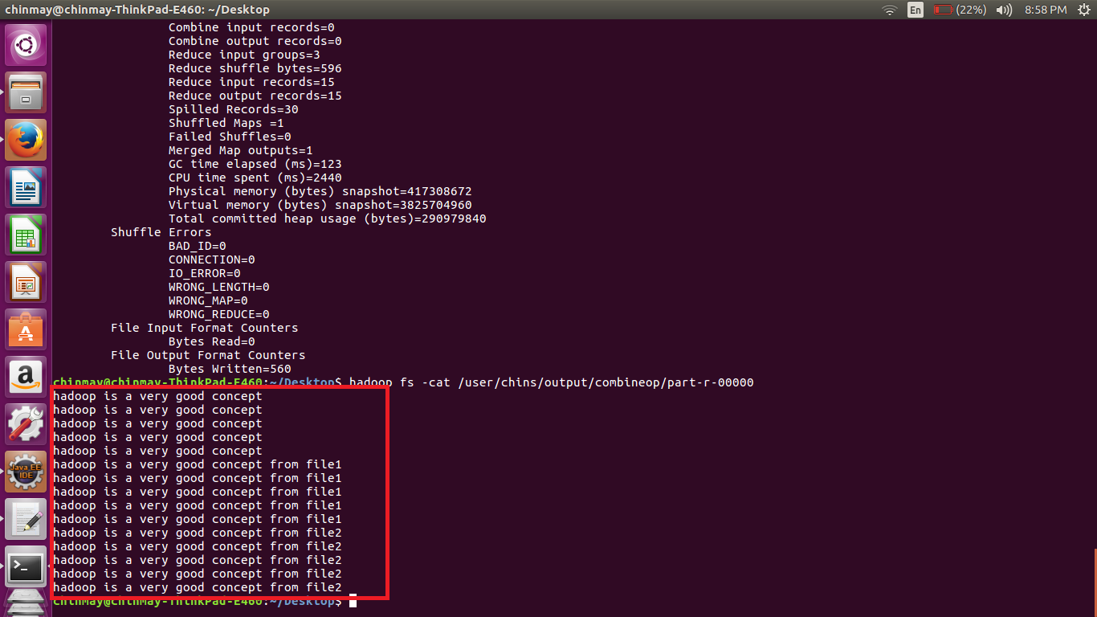the reducer is doing the default function and hence we get the output all three file like the files are concatenated.